
ECDSA Workshop – Digital Signatures Demo
Objective/Aim:
To explore and illustrate the functionality of the Elliptic Curve Digital Signature Algorithm by producing keys, generating a digital signature for a message, and verifying its authenticity.
Apparatus/Software Used:

- Computer with internet access
- Web Browser

Theory/Concept:
ECDSA (Elliptic Curve Digital Signature Algorithm) is a cryptographic technique used to create digital signatures.
It ensures authenticity, integrity, and non-repudiation of data.
Working Steps:
- Key Generation:
A random private key is selected, and the corresponding public key is computed using elliptic curve operations.
- Signature Creation:
The message is first hashed, and this hash is signed using the private key to generate the digital signature.
- Signature Verification:
The receiver uses the sender’s public key along with the message hash to confirm whether the signature is valid.
Benefits:
It offers strong security even with smaller key sizes when compared to RSA and is commonly used in blockchain systems such as Bitcoin and Ethereum.

Procedure:
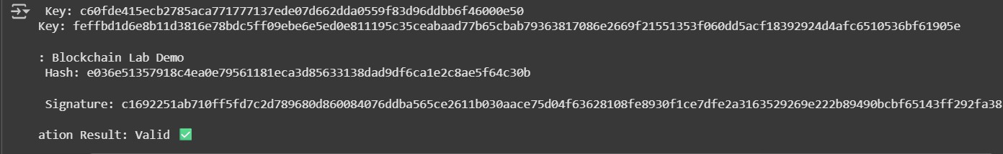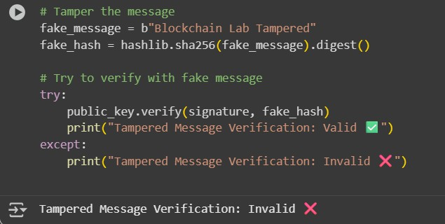

- Install the required cryptography library (pip install ecdsa).
- Generate an elliptic curve key pair (private and public keys).
- Take an input message (e.g., "Blockchain Lab Demo").
- Hash the message using SHA-256.
- Use the private key to sign the message hash → digital signature.
- Verify the signature using the public key and message hash.
- Observe that:
  - If the message or signature is altered, verification fails.
  - If unchanged, verification passes.
Observation Table:

Step | Input/Process | Output/Result
Key Generation | Random private key | Public key derived from EC multiplication
Message Input | "Blockchain Lab Demo" | Message ready for hashing
Hashing | SHA-256(Message) | 64-character hash value
Signature Generation | Private Key + Hash | Digital Signature
Signature Verification | Public Key + Message + Signature | Valid (if original) / Invalid (if tampered)

